* This is the board of the battery pack monitor we are designing.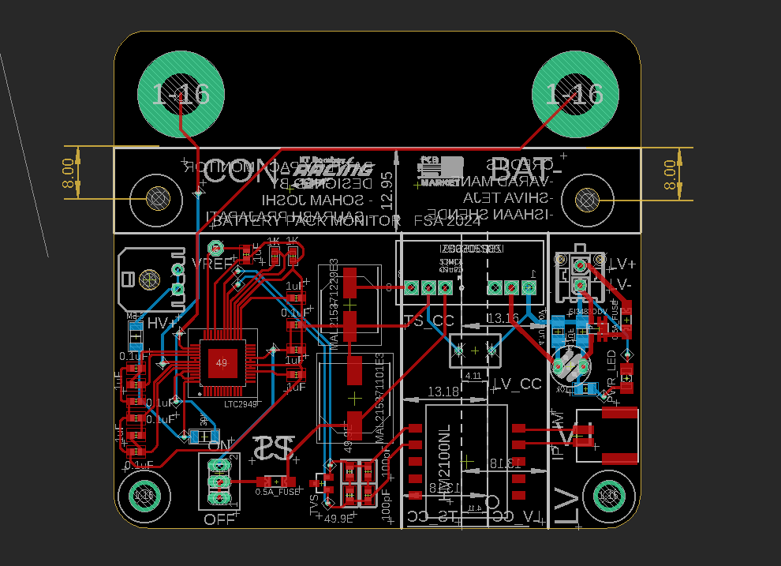

The IC used here is LTC2949 whose main role is to measure the voltages,current and other details of the HV system and the accumulator of the car.

The IC then sends the data to the master board via iso-spi communication and it has inbuilt features for this.

The IC is one of the peripheral in the daisy chain(series) communication system.

Low offset ΔΣ ADCs ensure accurate measurement of voltage and current with insignificant power loss. Continuous integration of current and power ensures lossless tracking of charge and energy delivered or received by the battery pack.

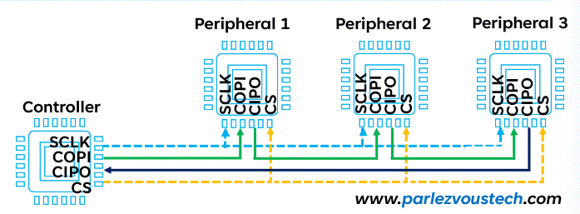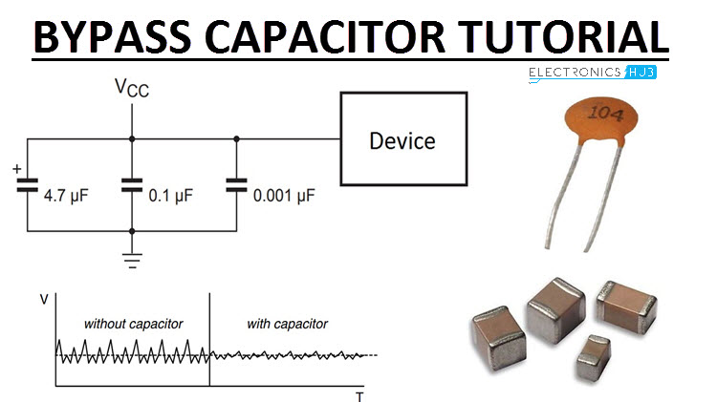

* The supply pins of IC have to be bypassed to respective grnd using capacitors of certain minimum capacitance.

The 4MHz Crystal Oscillator is a precision timing device used to provide a stable clock signal for electronic circuits.

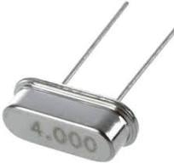

Note: DNC pins are ‘do not connect’ pins.

The operating range of the supply pins is around 4.5V to 14V.

* The supply pins are getting 12V as shown in the schematic.(the IC

Is an LV device.)

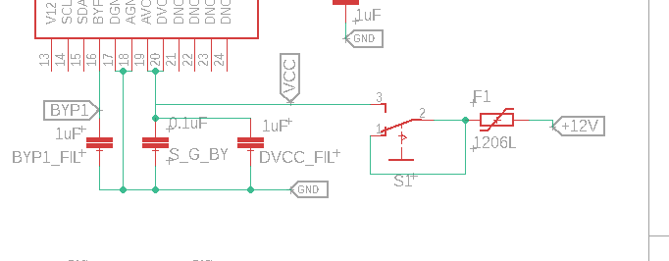

* EEPROM is an acronym that stands for Electrically Erasable Programmable Read-Only Memory.

MBIST is a self-testing and repair mechanism which tests the memories through an effective set of algorithms to detect possibly all the faults that could be present inside a typical memory cell whether it is stuck-at (SAF), transition delay faults (TDF), coupling (CF) or neighbourhood pattern sensitive faults (NPSF). It uses an inbuilt clock, address and data generators and also read/write controller logic, to generate the test patterns for the test.

**A**ll above are definitions and explanations of certain terms mentioned in the pin functions of the IC.

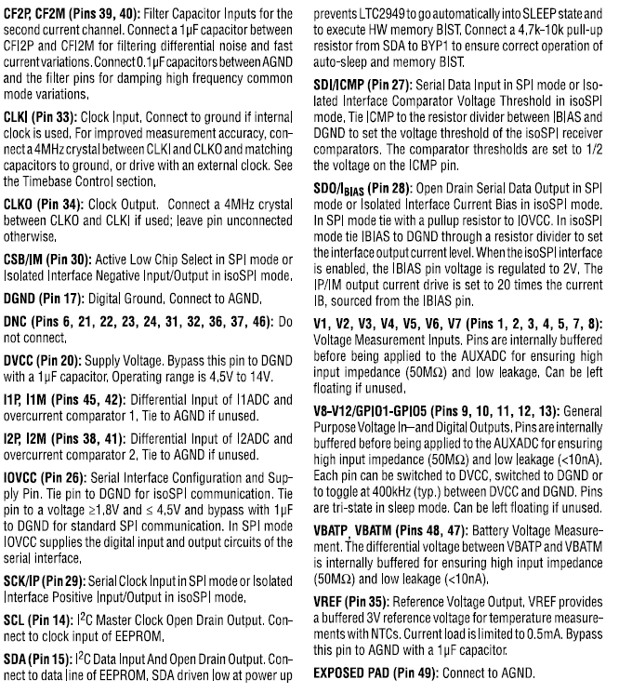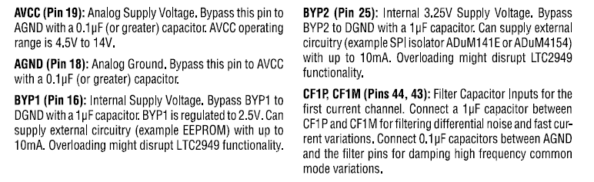

That’s all for pin functions.

**Circuit explanation(for BPM):**

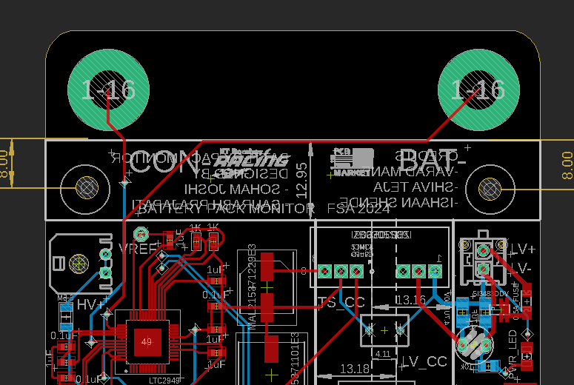

Two shunts are connected at the two drill holes above(green color).

From left one we get I1M and from right we get HV-.

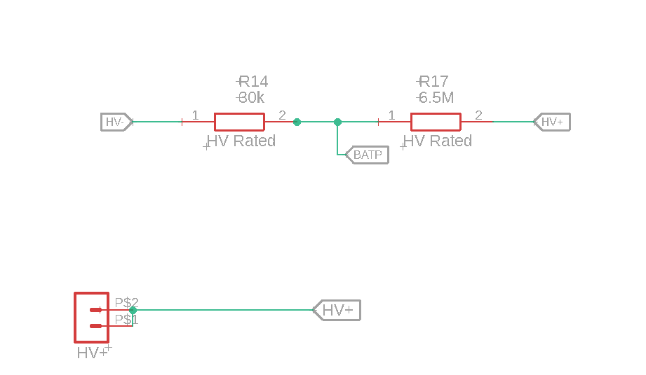

* One of the main function of the IC is to measure the voltage of the accumulator.
* This is done by measuring the difference between BATP AND BATM(HV-). HV- is just like a reference voltage.
* The HV+ node is connected to a voltage divider circuit with resistances 6.5M ohm and 30k ohm. The voltage taken from the node is BATP.
* After the differential voltage(analog) is taken the IC processes it and sends the digital data to the master via iso spi communication .